Functions

Look at this code:
def show_greeting():
print("Hello, Python learner!")
show_greeting()
print("Welcome to Python.")

What do you think this code will display?
Click or tap here to enter text.

Run the code. Compare the result with your prediction:
Click or tap here to enter text.

Let’s investigate! Answer the questions below:
- Why does Python not run a function body when it first reads the def statement?
Click or tap here to enter text.

- What happens if the function name is written without parentheses where a call is intended?
Click or tap here to enter text.

- Why must the function body be indented?
Click or tap here to enter text.

- Which two messages appear, and in what order?
Click or tap here to enter text.

Functions

Look at this code:
def show_greeting():
print("Hello, Python learner!")
show_greeting()
print("Welcome to Python.")

Use the code above to help you. After completing each challenge below, run your program to test that it works correctly. Save each completed challenge program in a new file.

Programming Challenges

Challenge 1
Change the example by adding a second function called show_rules() that displays "Save your work often." and "Ask for help when stuck." Call show_rules() after show_greeting() and before the final message.
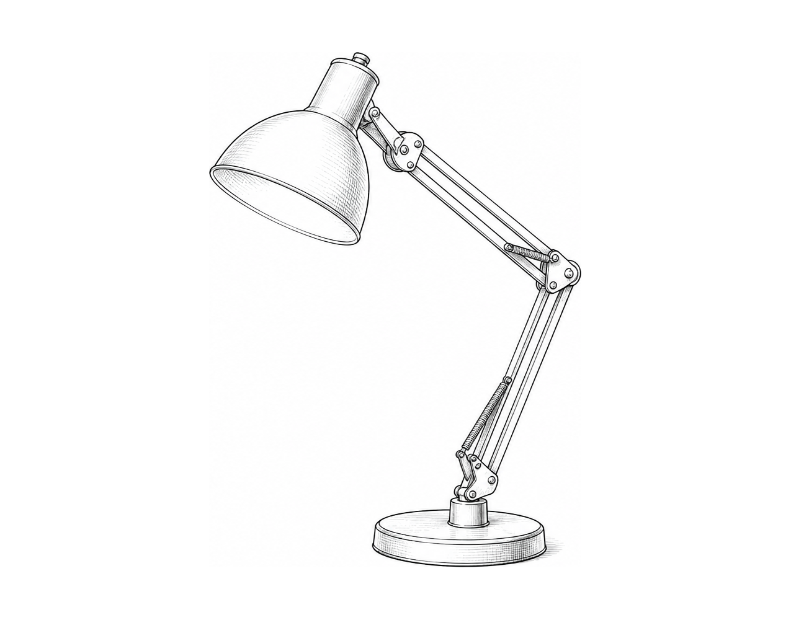

Challenge 2
Extend the example with a function called show_line() that displays a line of dashes. Call show_line() before and after show_greeting() so the greeting appears inside a banner.

Challenge 3
Create a program with two functions: show_intro() displays a welcome message and show_goodbye() displays a farewell. In the main program, call show_intro(), ask for the user's name, display "Nice to meet you," followed by the name, then call show_goodbye().

Functions

Fix the code!

This code has errors! Look closely at the code to find the problems:

def show_greeting():
print(greeting_message)
show_greeting()
print("Welcome to Python.")

Rewrite the whole program in the box below with fixes to the errors.
Click or tap here to enter text.

After you are confident that you fixed all the errors, copy the code from the box and run it.

Did it work correctly on your first try? Did you find all the errors?
Click or tap here to enter text.

